PROJECT TITLE

A course project report submitted in partial fulfilment of the requirement
of
DEVOPS AND FULLSTACK
by

M.Vikas (2303A52190)
V.Manikanta Varaprasad (2303A52130)
K.Akshith (2303A52436)

Under the guidance of
Dr. N.VENKATESH
Asst. Professor, Department of CS & AI


SR University, Warangal
APRIL-2026
ABSTRACT
The main aim of this project presents the implementation of a cost-effective Home Automation System with remote control. This framework is intended to help and give help to satisfy the needs of the elderly and the handicapped at houses. Additionally, the idea of a home automation system will improve the normal living status of houses. This system is designed to control electrical devices throughout the house with ease of installing it, ease of use, and cost-effective design and implementation. Our main idea is to develop a system to provide people a living environment with security, comfort, environmental protection, and intelligence. We introduced a technology which will not only save our money and time but will prove to be beneficial and effective for the economy.

CONTENTS

ABSTRACT ii

CONTENTS

ABSTRACT ......................................................... ii

Chapter No. Title Page No.

1 INTRODUCTION 01
1.1 About the Project 01
1.2 Objectives 02
1.3 Scope of the Project 03

2 LITERATURE REVIEW 04
2.1 Overview 04
2.2 Existing LMS Platforms 05
2.3 Tools and Technologies Used 07

3 SYSTEM DESIGN AND METHODOLOGY 09
3.1 System Architecture 09
3.2 Modules Description 10
3.3 Technologies Used (MERN Stack) 12
3.4 Database Design 13

4 IMPLEMENTATION AND RESULTS 15
4.1 System Implementation 15
4.2 Features of LMS 16
4.3 Results and Screenshots 18

5 CONCLUSION AND FUTURE WORK 20
5.1 Conclusion 20
5.2 Future Scope 21

REFERENCES 22

- PROJECT TITLE: Learning Management System (LMS) using MERN Stack
2. ABSTRACT
The main aim of this project is to design and develop a Learning Management System (LMS) using modern full-stack technologies including React, Node.js, Express.js, and MongoDB. The system provides a digital platform for students and instructors to manage, access, and deliver educational content efficiently.
The LMS allows users to register, log in, enroll in courses, and track their learning progress. Instructors can create and manage courses, upload study materials, and monitor student performance. The system ensures secure authentication, user-friendly interface, and scalable backend architecture.
This project demonstrates the implementation of a full-stack web application integrated with DevOps practices such as version control, containerization, and continuous deployment. The LMS improves accessibility to education, enhances learning experience, and provides a flexible and cost-effective solution for online education systems.
- CHAPTER 1 – INTRODUCTION
  - About the Project:
The Learning Management System (LMS) is a web-based application designed to facilitate online learning and course management. It enables students to access educational resources anytime and anywhere, while instructors can manage courses, upload content, and track student progress. The system is built using the MERN stack, which includes React for the frontend, Node.js and Express.js for backend services, and MongoDB for database management.
1.2 Objectives
- To develop a user-friendly LMS platform
- To enable course creation and management
- To allow students to enroll and track progress
- To implement secure authentication and authorization
- To build a scalable full-stack web application using MERN
- CHAPTER 2 – LITERATURE REVIEW
Learning Management Systems have gained significant importance in modern education. Platforms such as Moodle and Coursera demonstrate how LMS solutions can deliver scalable and interactive learning experiences. Research indicates that LMS platforms improve accessibility, engagement, and knowledge retention among learners.

CHAPTER 3 – METHODOLOGY
3.1 System Architecture
The system follows a client-server architecture. The frontend is developed using React, while the backend is built using Node.js and Express.js. MongoDB is used as the database to store user and course data.
  - Modules
User Authentication (Login/Register)
Course Management
Student Enrollment
Dashboard System
Admin Panel
  - Technologies Used
4.1 Results
The LMS system was successfully developed and tested. Users were able to register, log in, enroll in courses, and access learning materials.
4.2 Discussion:
The system provides a smooth and responsive user experience. The integration of frontend and backend ensures efficient data flow and real-time updates.

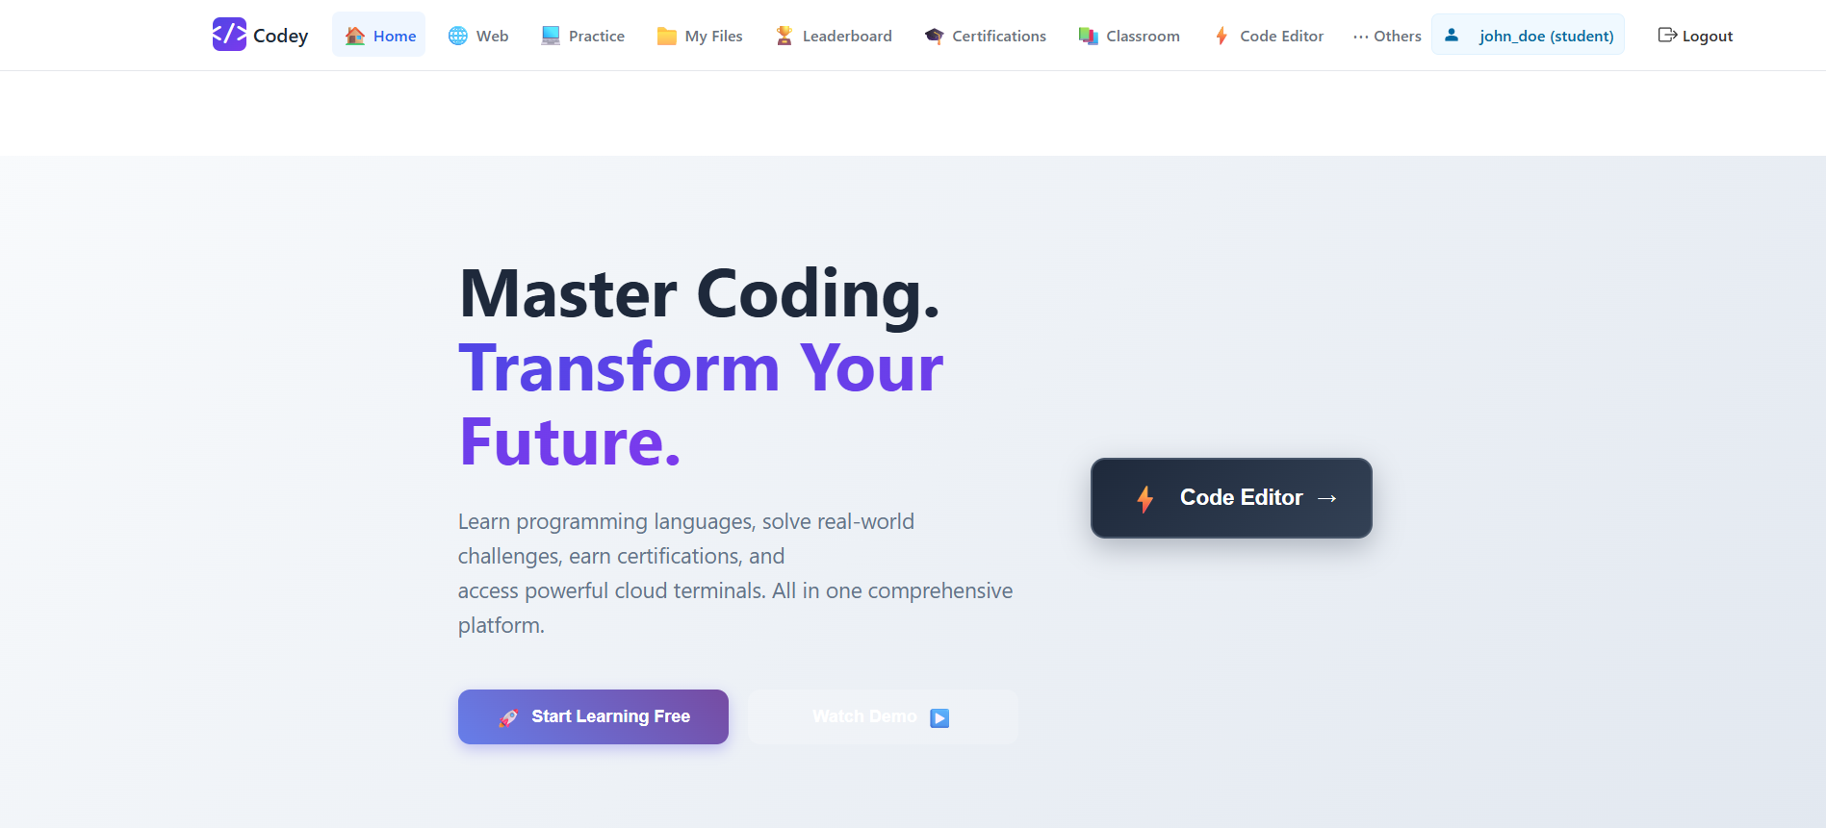
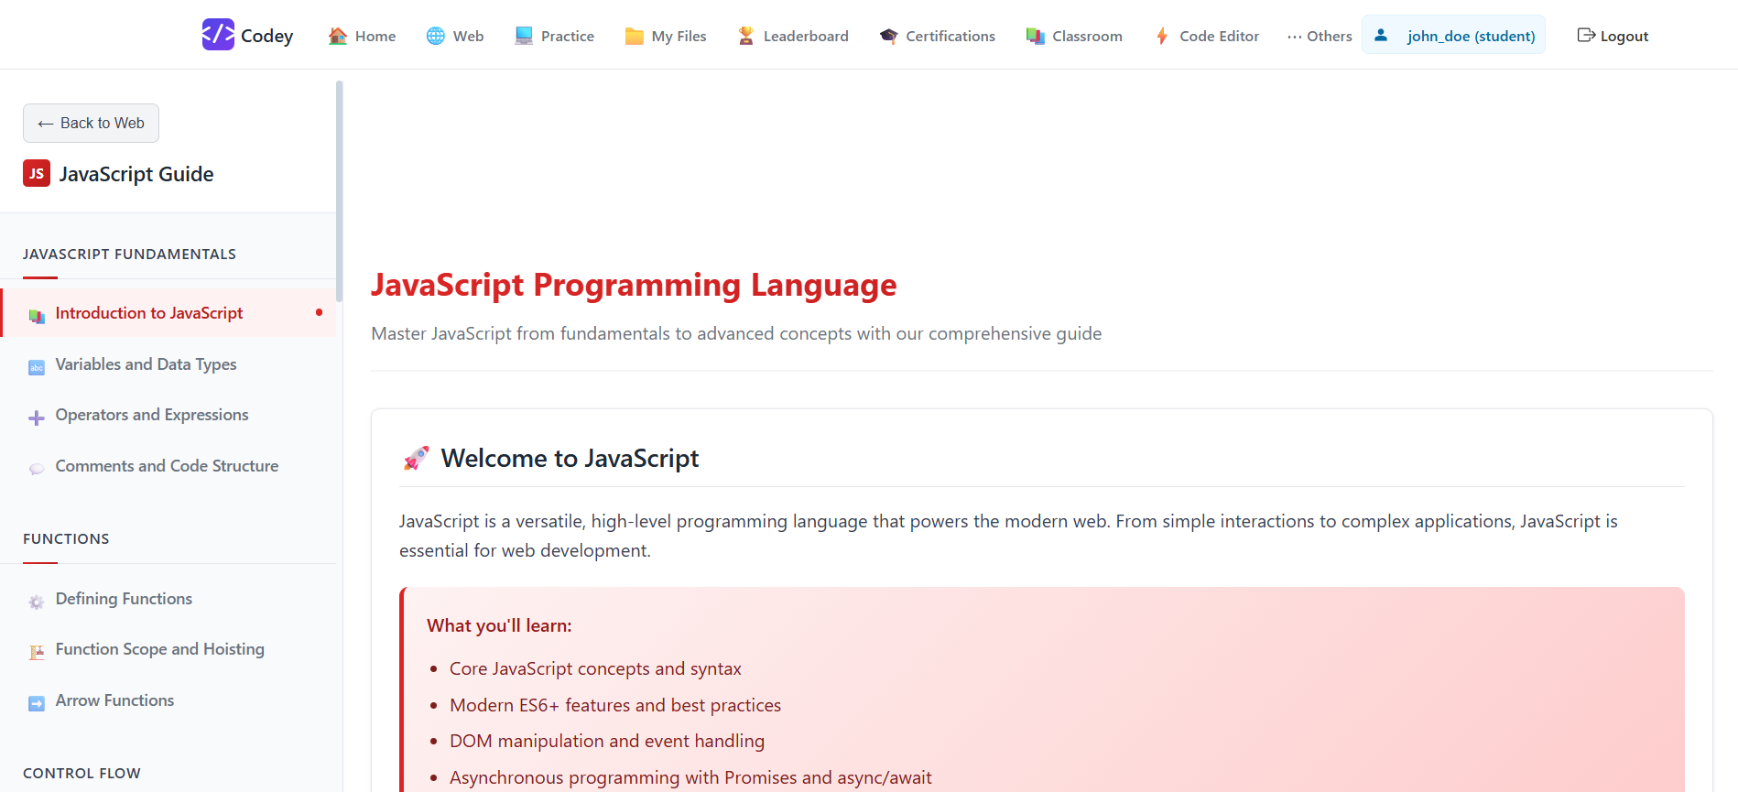
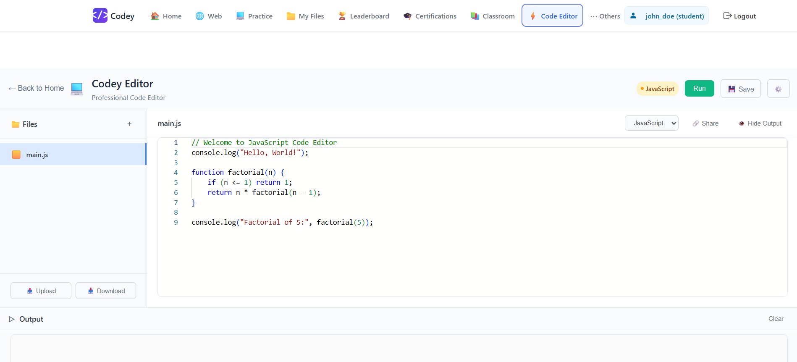

CHAPTER 5 – CONCLUSION
5.1 Conclusion
The project successfully demonstrates the development of a full-stack Learning Management System using the MERN stack. It provides a scalable and efficient solution for online education.
5.2 Future Scope
• Video streaming integration
• AI-based course recommendations
• Mobile app version
• Payment gateway integration

